Vending Machine with Change System

A vending machine is an automated machine that provides items such as snacks, beverages, cigarettes and lottery tickets to consumers after cash, a credit card, or other form of payment is inserted into the machine or otherwise made.

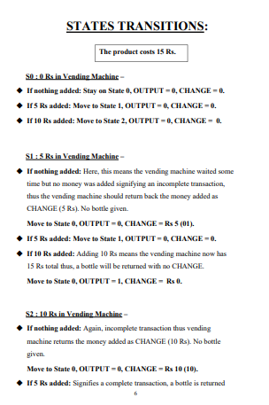

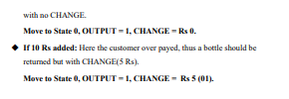

Verilog

A Verilog design consists of a hierarchy of modules. Modules encapsulate design hierarchy, and communicate with other modules through a set of declared input, output, and bidirectional ports. Internally, a module can contain any combination of the following: net/variable declarations (wire, reg, integer, etc.), concurrent and sequential statement blocks, and instances of other modules (sub-hierarchies). Sequential statements are placed inside a begin/end block and executed in sequential order within the block. However, the blocks themselves are executed concurrently, making Verilog a dataflow language. Verilog's concept of 'wire' consists of both signal values (4-state: "1, 0, floating, undefined") and signal strengths (strong, weak, etc.). This system allows abstract modeling of shared signal lines, where multiple sources drive a common net. When a wire has multiple drivers, the wire's (readable) value is resolved by a function of the source drivers and their strengths. A subset of statements in the Verilog language are synthesizable. Verilog modules that conform to a synthesizable coding style, known as RTL (register-transfer level), can be physically realized by synthesis software. Synthesis software algorithmically transforms the (abstract) Verilog source into a netlist, a logically equivalent description consisting only of elementary logic primitives (AND, OR, NOT, flip-flops, etc.) that are available in a specific FPGA or VLSI technology. Further manipulations to the netlist ultimately lead to a circuit fabrication blueprint (such as a photomask set for an ASIC or a bitstream file for an FPGA).

Result

**1. Adding 5 Rs three times consecutively**

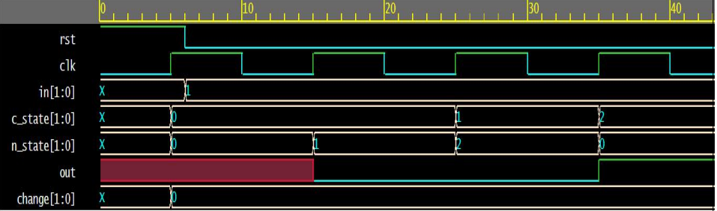

**2. Adding 5 Rs and then 10 Rs**

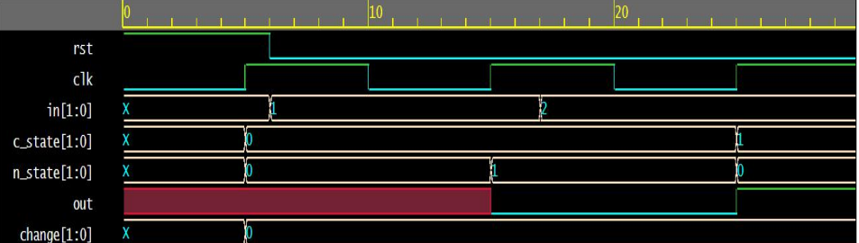

**3. Adding 10 Rs two times**

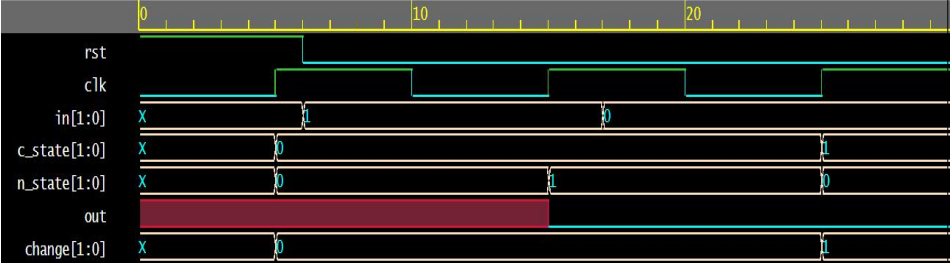

**4. Adding 5 Rs and then nothing**

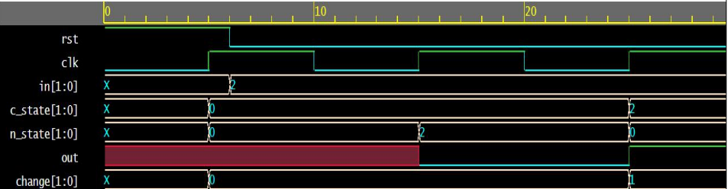

**5. Adding 10 Rs and then nothing**

